**Step 1: TortoiseSVN**

Install **TortoiseSVN** → Right Click in the folder where you want to checkout this project

→ choose **SVN Checkout**

**Copy URL of repository :** [**https://hp-pc:8443/svn/FireSeverityAppProject/**](https://hp-pc:8443/svn/FireSeverityAppProject/)

Please check out project: FireSeverityAppProject

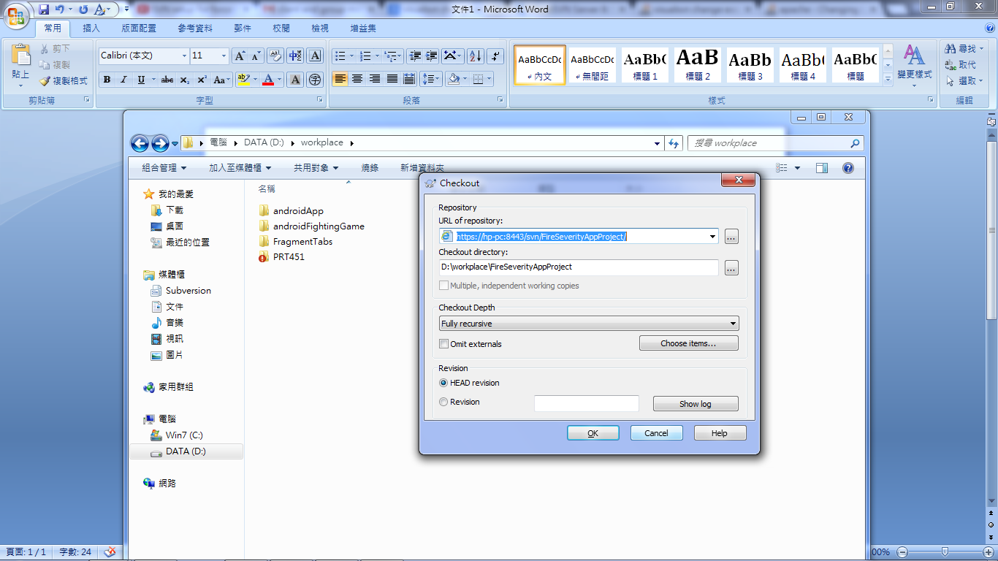

Two folder included in **FireSeverityAppProject**

***Doc :*** documentation of this project.

***FireSeverityApp:*** Android Project source Code



**Step2: Eclipse SVN plugin**

Install **SVN plugin** in Eclipse.

In Eclipse → File → Import → SVN (project from SVN) →

Create a new repository location:

**URL :** [**https://hp-pc:8443/svn/FireSeverityAppProject/**](https://hp-pc:8443/svn/FireSeverityAppProject/)

**Authentication:** (please check the Authentication file of your User name and Password)

|  |  |
| --- | --- |
| User | Password |
| Arcelie | 0000 |
| Pankaj | 0000 |
| Kavy | 0000 |

